# Technopreneurship in Strategic Management Context

## Multidimensional SWOT Analysis

### Ordinary SWOT Analysis

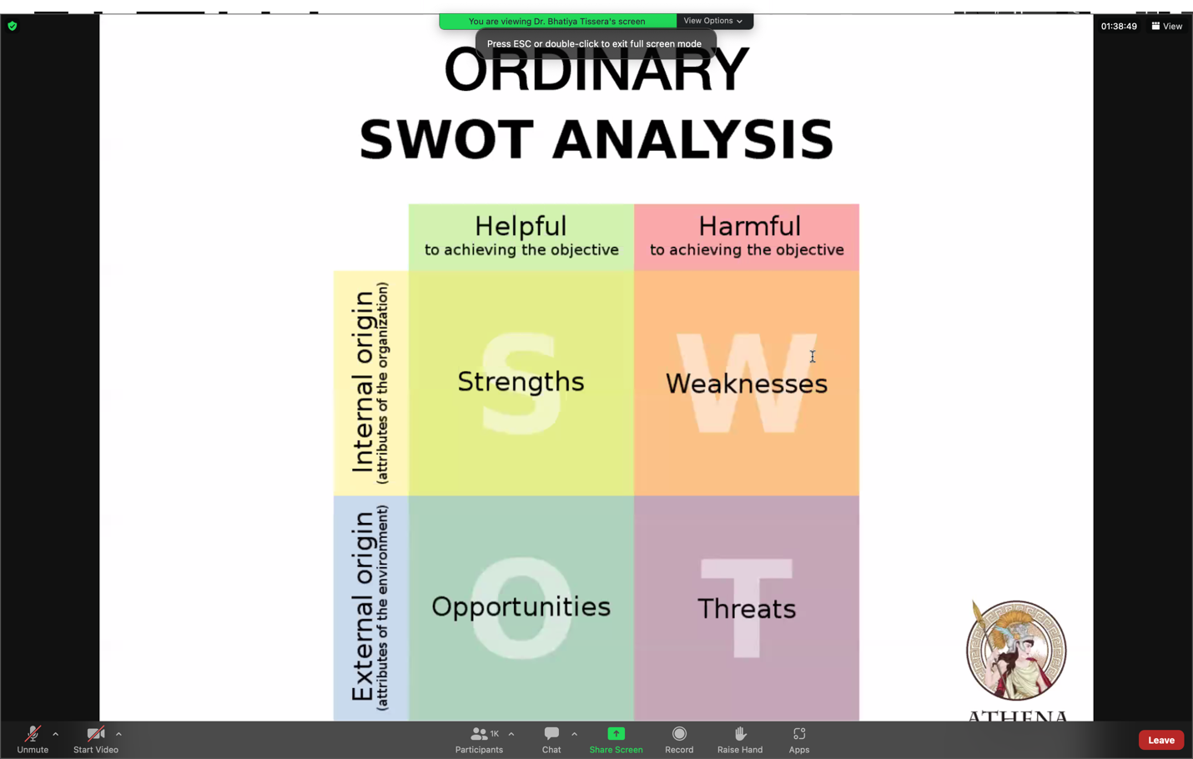

### Multidimensional SWOT Analysis for Dynamic Environments in the Reality

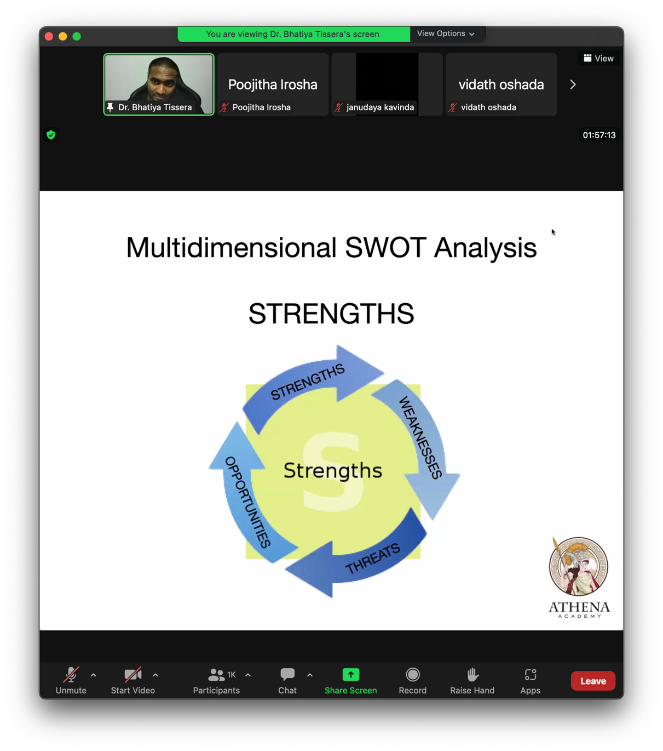

### Case Study: Ivory Trade in Africa

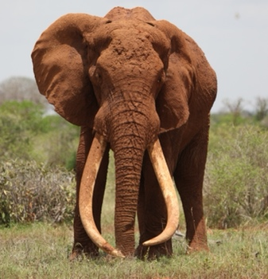අ​​ලින්ගෙ strength ​එක තමයි දළ තියෙන එක.

​ **SWOT Analysis ​එක වැරදියට කරොත් හොම්බෙන් යනු ලැබේ.**

* Strength එකක් අදුරගත්තට පස්​සෙ ඊළ​ගට ​ඒ strength ​එක ඇතුළෙ තියෙන weakness ​එක identify ​කර ගන්න ඕනි.
* ​ඒ identify ​කර ගත්ත weakness ​එකට weapon එ​කක් හදන්න ඕනි.
* Bigest strength එ​ක නිසා threats ඇතිවෙන්න ඉඩ තියෙනවා.
* Biggest strength එ​ක නිසා opportunities ​​හම්බෙන්න පුලූවන් ඒ වගේ ම ඒ opportunities trap එකක් විය හැකියි.
* සතුරගෙ biggest strength ​එකම opportunity ​එකක් විදියට.
* Strength ​එක කියල හිතාන ඉන්න එකේ ඇත්තම strength ​එක isolate ​කර ගන්න ඕනි. (80% 20% Theory)

**Once you identify your true strength:** **That the impact of your army may be like a grindstone dashed against an egg – this is effected by the science of weak points and strong.**

**Strength: Energy may be likened to the bending of a crossbow; decision, to the releasing of a trigger.**

Decision matters to Strength, Opportunity, Threat, Weakness

**The clever combatants looks to the effect of combined energy, and does not require too much from individuals. Hence his ability to pick out the right men and utilize combined energy.**

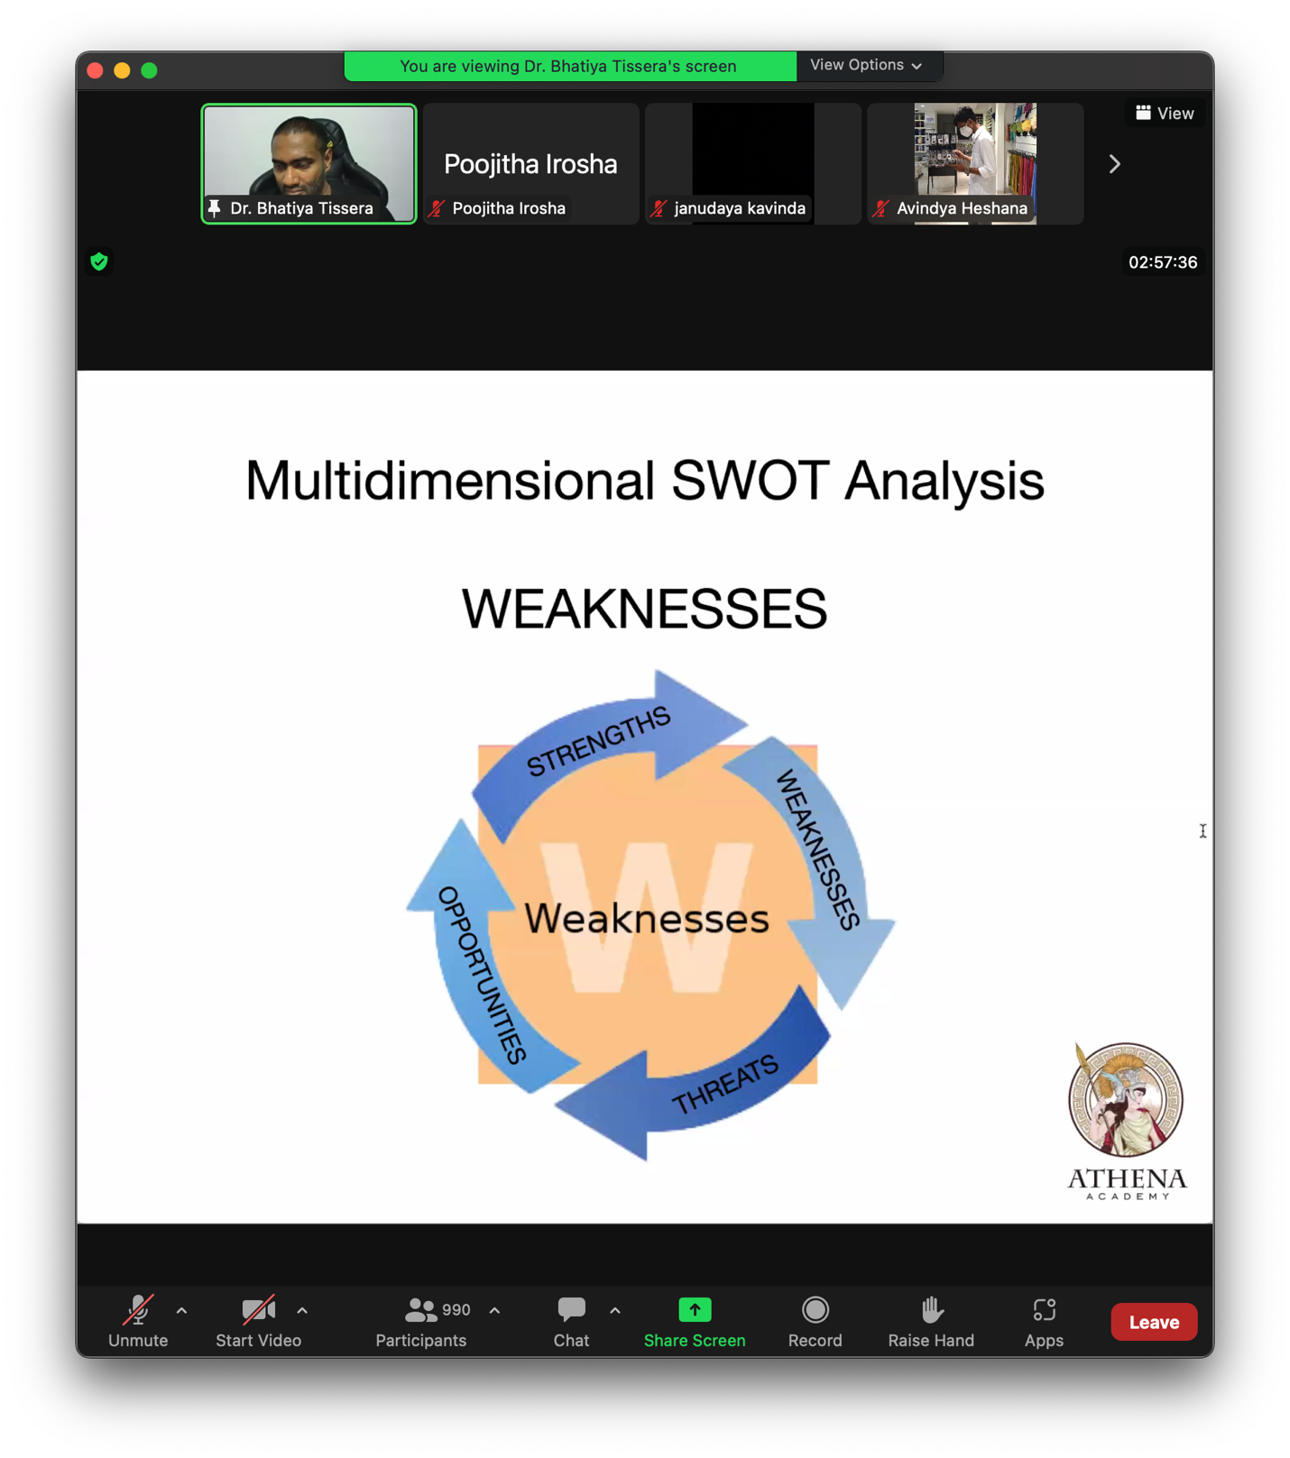

* Weakness ​එක ඇතුලෙ තියෙන ​ඇත්ත​ම weakness ​එක identify ​කර ගන්න ඕනි.

**Could your biggest weakness become your greatest strength?**

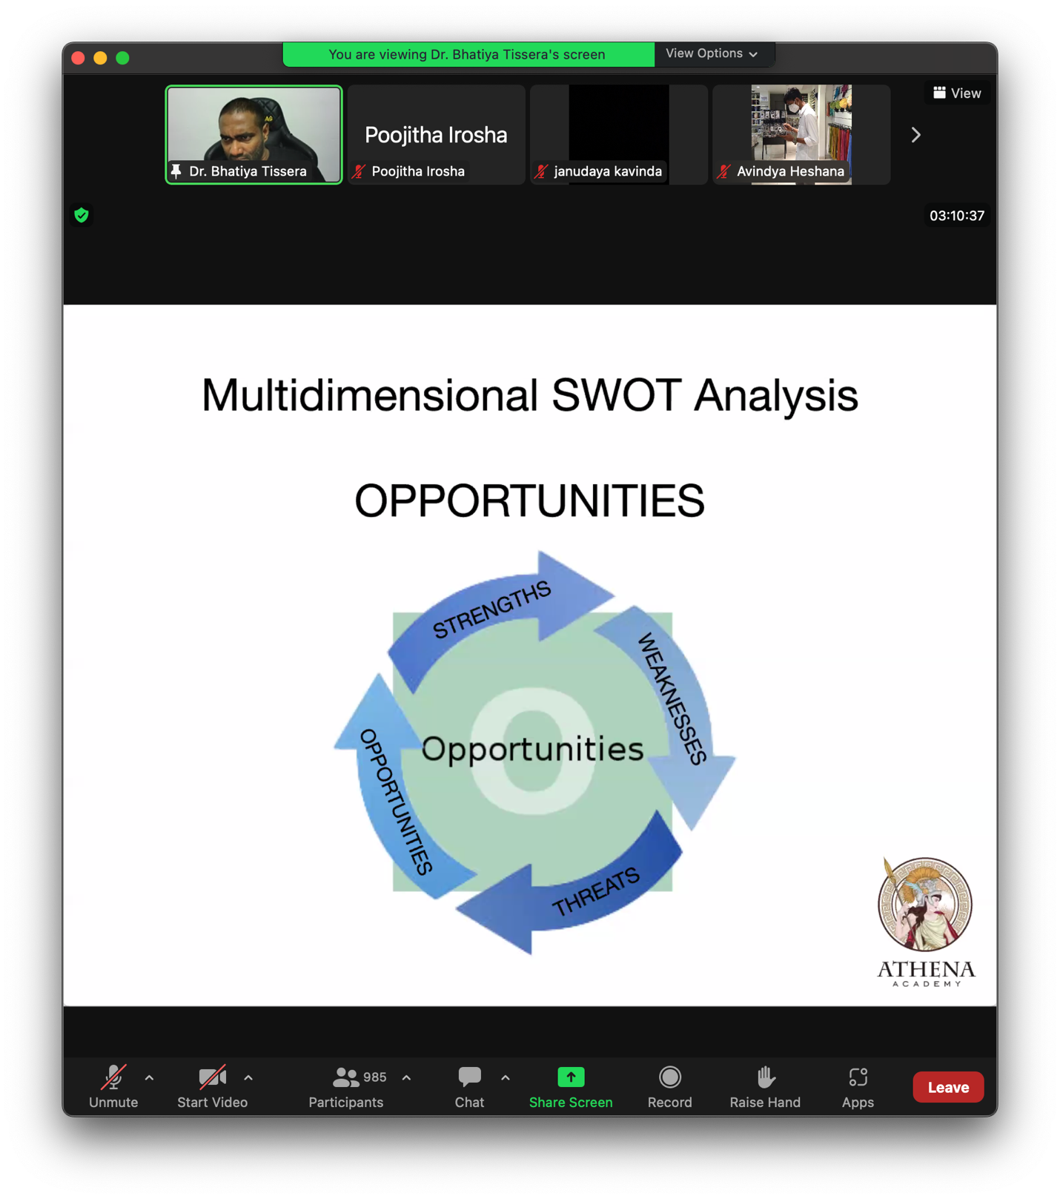

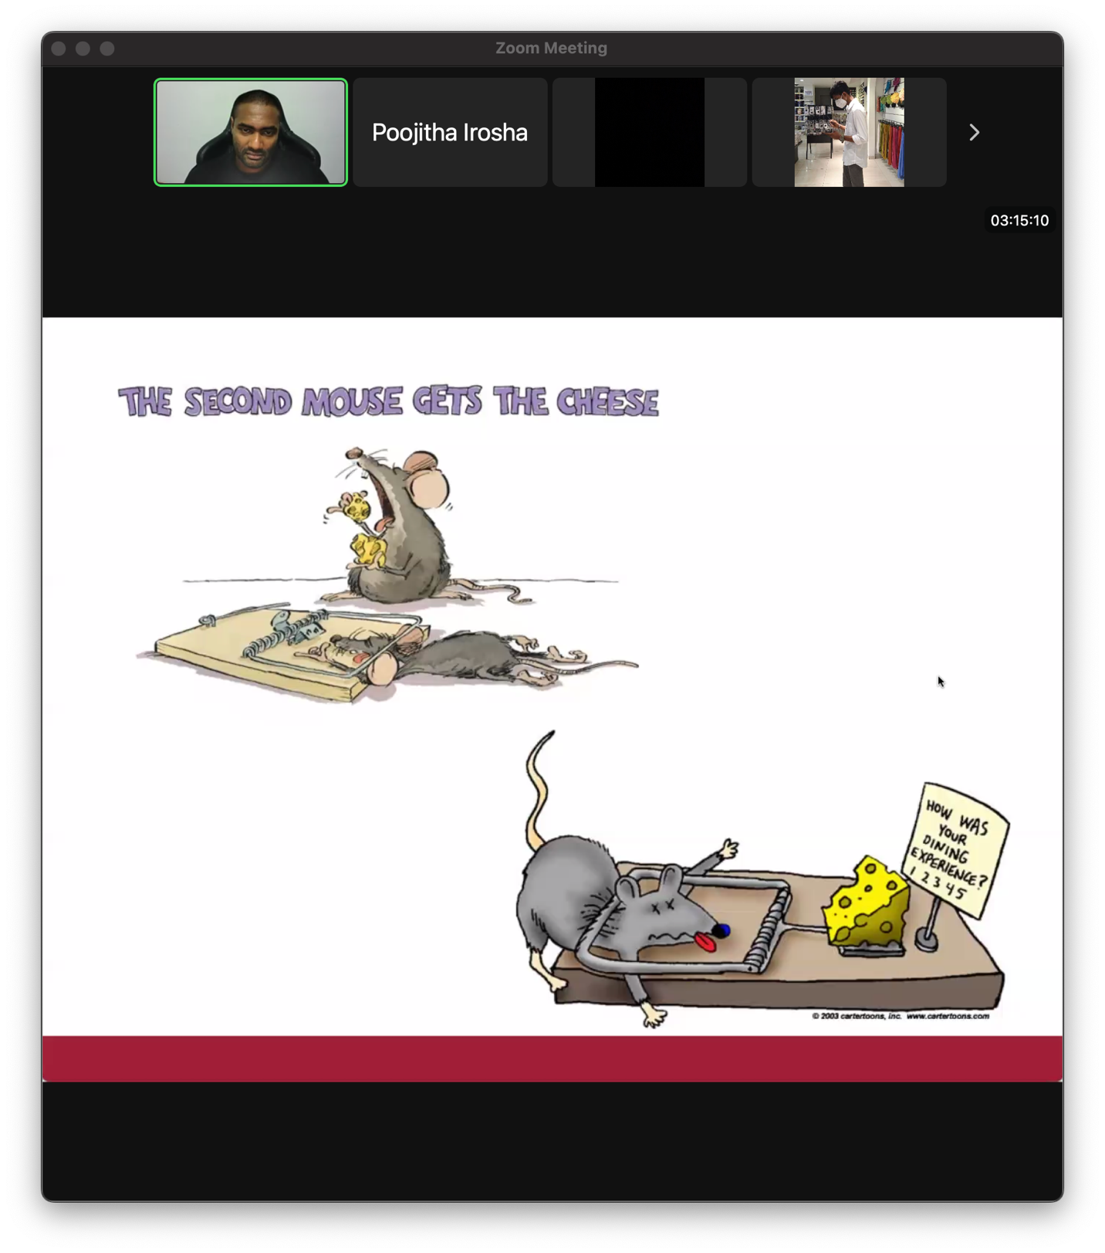

**වැල යන පැත්තට මැස්ස ගහන්න එපා. Life Map ​එක ගහන්න එතකොට වරදින්නේ නැත.**

* Opportunity ​එක ඇතුළෙ තියෙන ඇත්තම opportunity ​එක isolate ​කර ගන්න ඕනි.

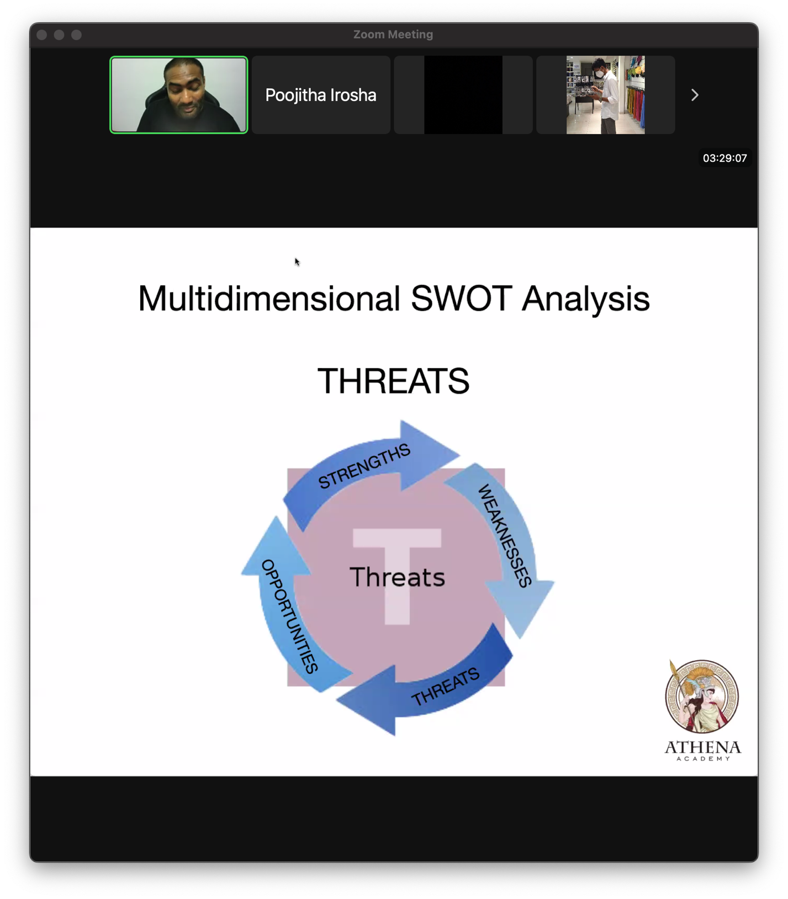

* Threat ​එක කියල හිතාගෙන ඉන්න එක ඇත්තම threat එ​ක නොවෙන්න පුළුවන්.
* Biggest threat එ​​ක ​ඔයාගෙ biggest strength ​එක සහ biggest opportunity ​එක කර ගන්න පුළුවන්.

**The quality of decision is like the well-timed swoop of a falcon which enables it to strike and destroy its victims**

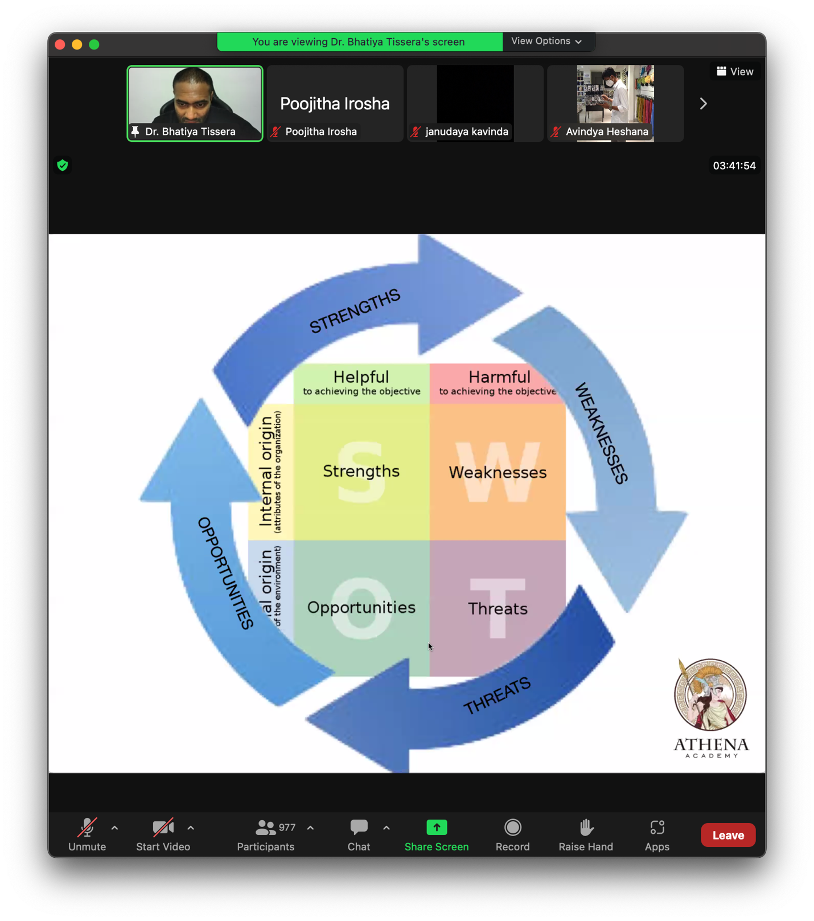

## PESTLE Analysis

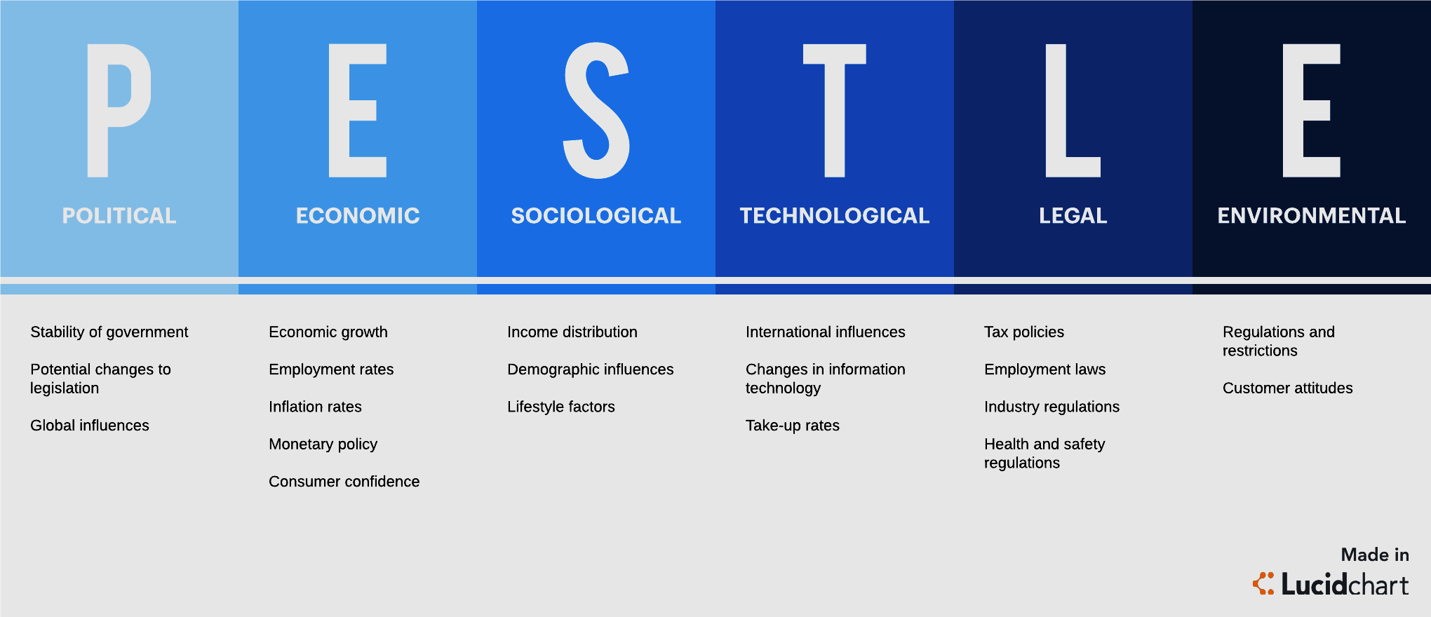

A PESTLE analysis provides contextual information about the business direction, its brand positioning, growth targets, and risks (such as another pandemic) to productivity. It can help determine the validity of existing products and services and define new product development

**CONTEXT**

*Remember:*

A single statistic doesn’t tell the whole story.

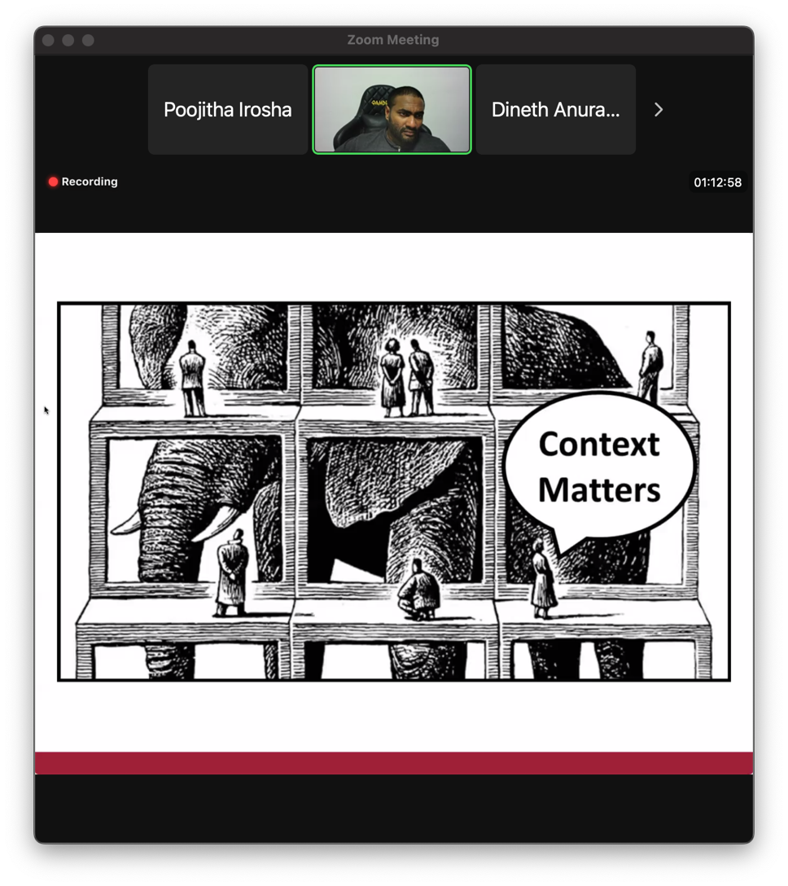

අන්දය අලියට ගහනව වගේ.

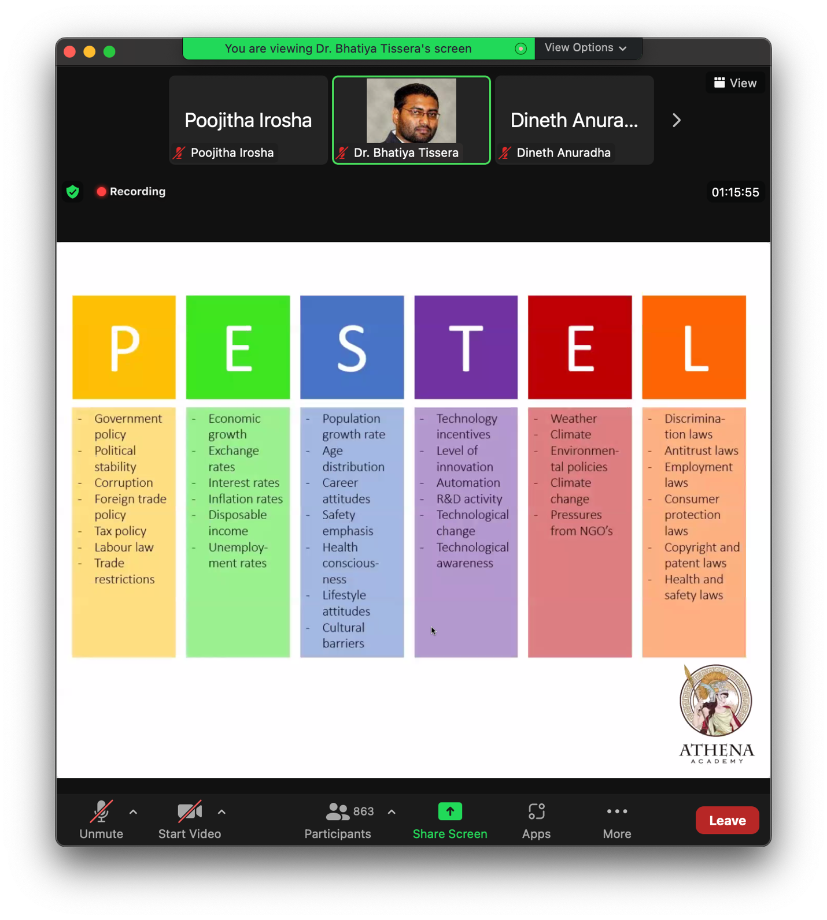

Population growth rate

චීනයේ එක් දරු ප්‍රතිපත්තිය කියල එකක් තිබ්බා. දෙවෙනි දරුවෙක් ලැබුනොත් ආර්මි එකෙන් මරල දාන්ව ඉපදුන ගමන්ම.

## Laying Plans

Generation to generation planning as a country.

###### British Ceylon Period

The british ceylon period is the history of Sri Lanka between 1815 and 1948 (133 years)

###### 5 Generations

​අපි රටක් සම්බන්ධයෙන් plan එකක් generate කරද්දි ඒක generation to generation වෙන්න ඕනි.

###### Dutugemunu the Great

He reigned from 161 BC to 137 BC. He is renowned for reuniting the whole island of Sri Lanka by defeating and overthrowing Elara,

Dynamic Nature of Attacking and Defensing.

Plan එකක් කියන්නෙ ආකෘතියක්.

All about timing

The quality of decision is like a well timed

###### Maha Ummagga Jataka

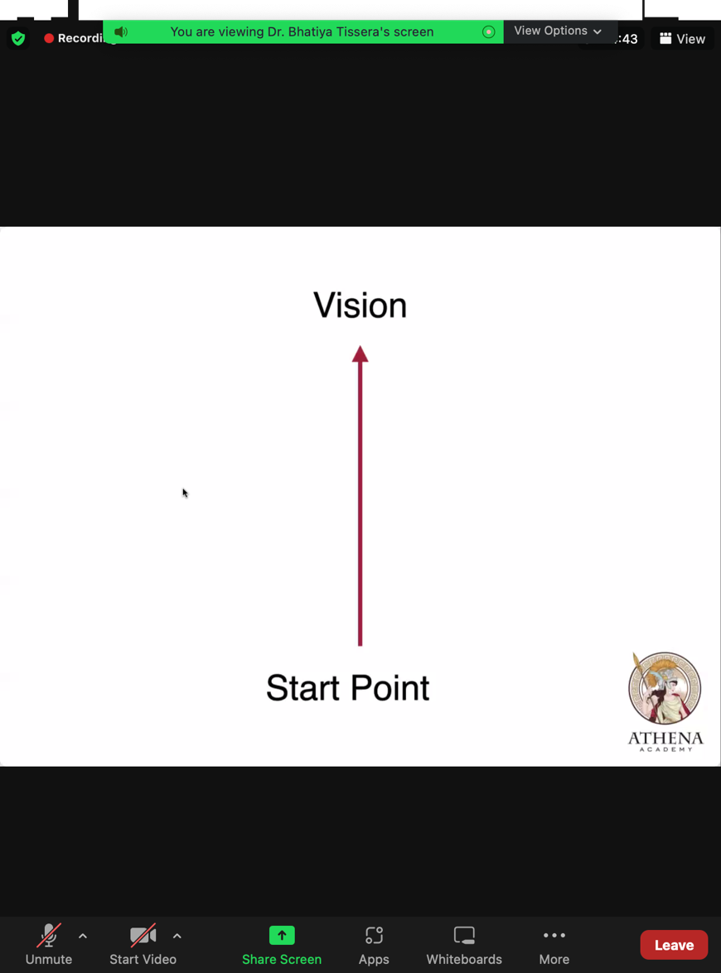

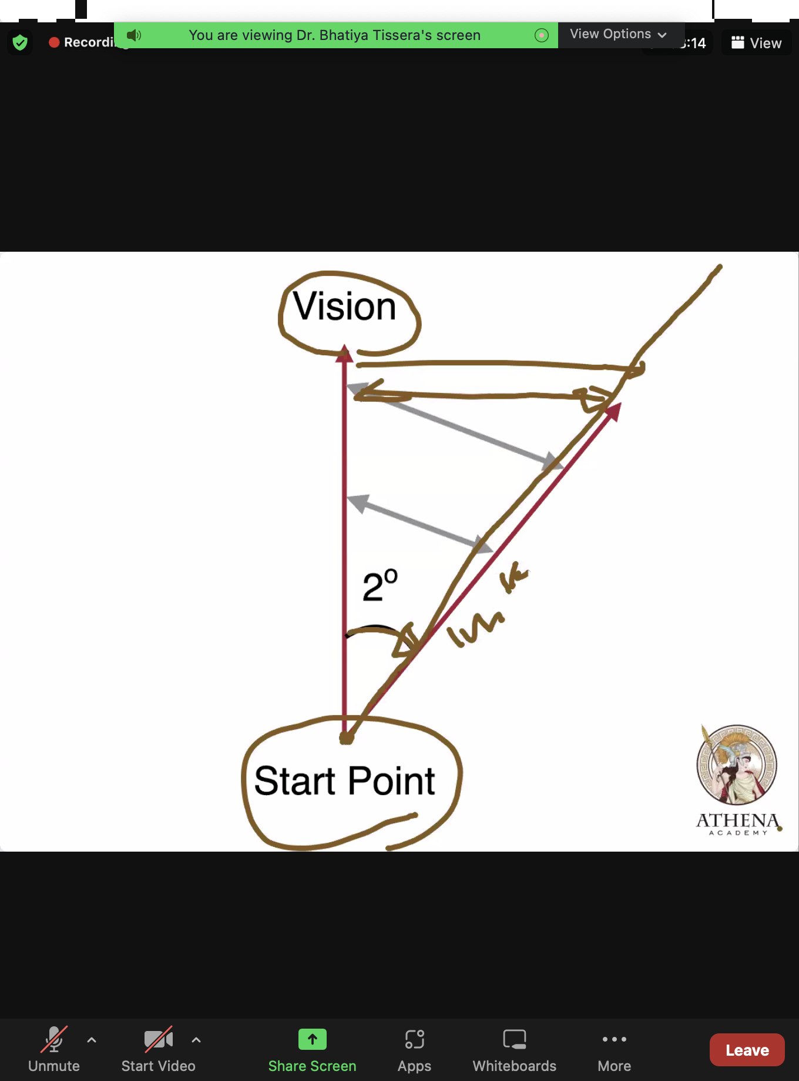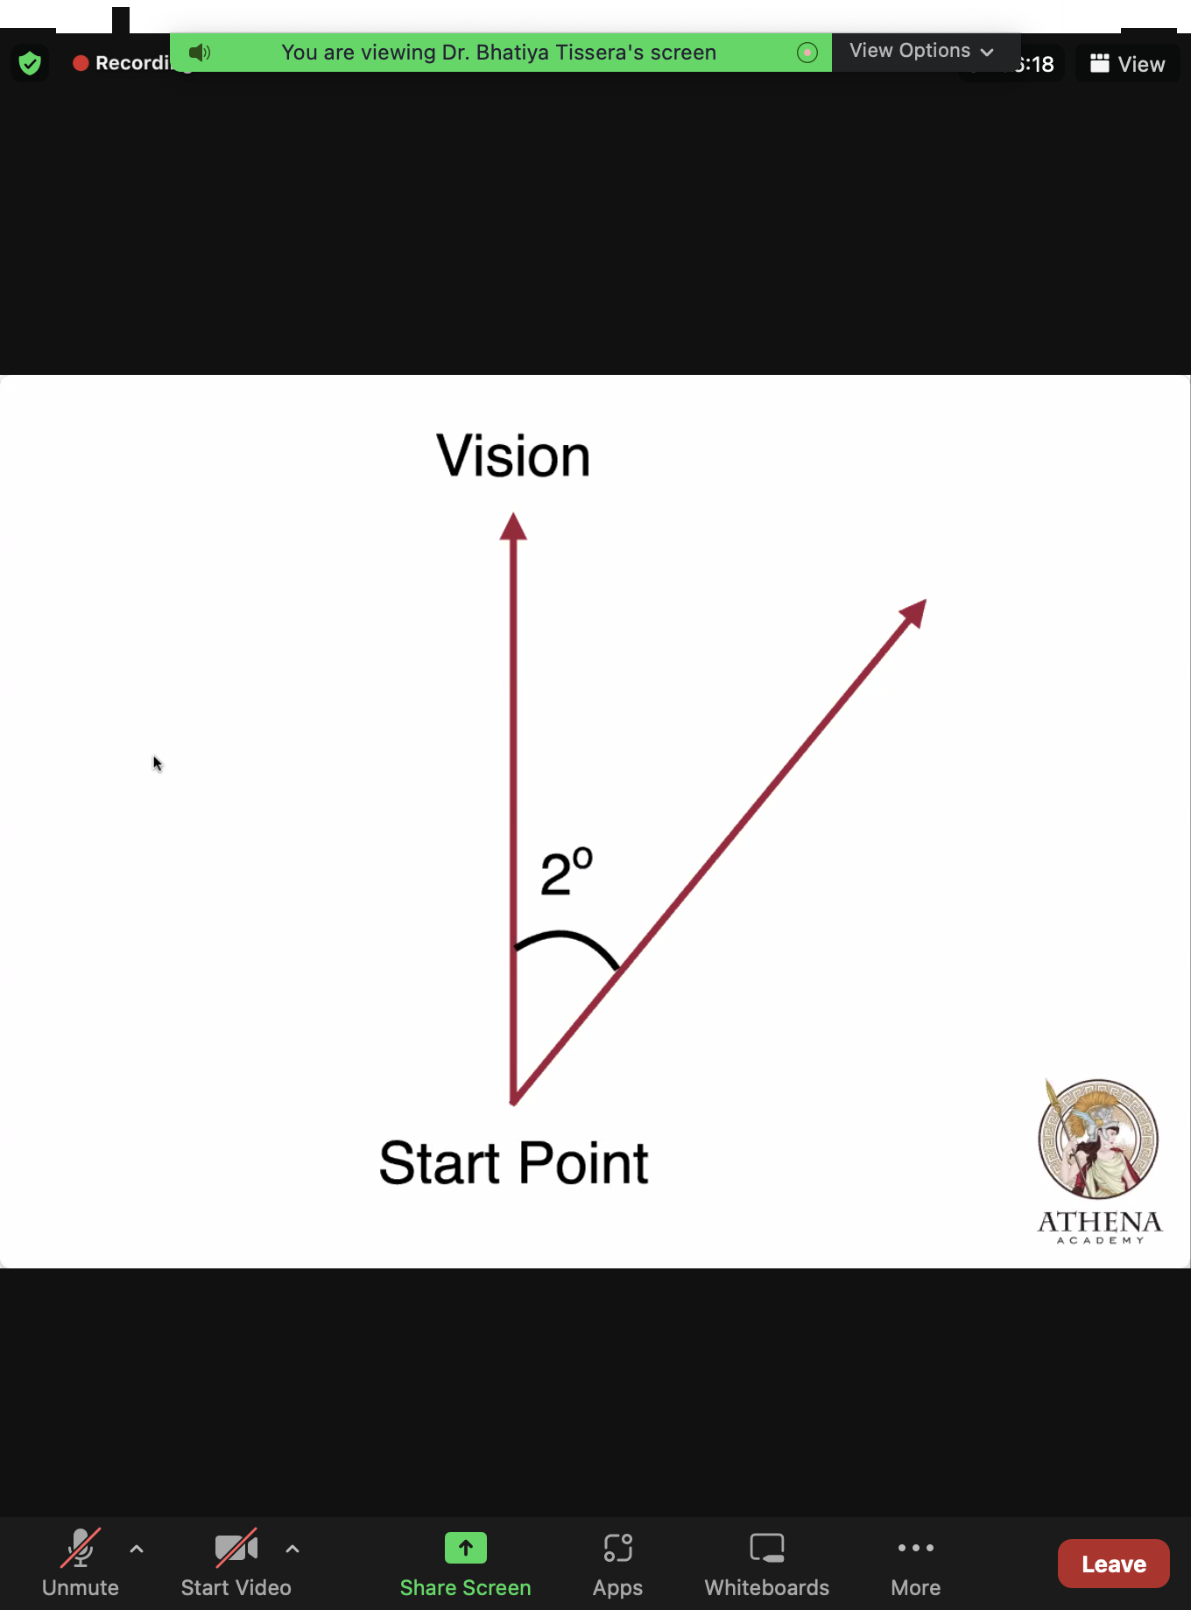

Vision එකෙන් එක අංශකයක්වත් deviate ​වෙන්න බෑ

## One degree matters

# Art of War

## The use of Spices

1. Sun Tzu said: Raising a host of a hundred thousand men and marching them great distances entails heavy loss on the people and a drain on the resources of the State. The daily expenditure will amount to a thousand ounces of silver.

There will be **commotion** at home and abroad and men will drop down exhausted on the high-ways. As many as seven hundred thousand families will be impended in their labor.

1. Hostile armies may face each other for years, striving for the victory which is decided in a single day.  
     
   This being so, to remain in ignorance of the enemy’s condition simply because one grudges the outlay of a hundred ounces of silver in honors and emoluments, is the height of inhumanity.
2. One who acts thus is no leader of men, no present help to his sovereign, no master of victory.
3. Thus, what enables the wise sovereign and the good general to strike and conquer, and achieve things beyond the reach of ordinary men, is foreknowledge.
4. Now this foreknowledge cannot be elicited from spirits; it cannot be obtained inductively from experience, nor by any deductive calculation.
5. Knowledge of the enemy’s disposition can only be obtained from other men.
6. Hence the use of spices, of whom there are five classes:
   1. Local spies;
   2. Inward spies;
   3. Converted spies;
   4. Doomed spies;
   5. Surviving spies;

## In spying, what not to do as a great strategist

## The Dark Side of Spying

## The Ultimate Mastery of Spying